**Task Name:**

Import Data into MySQL for cleansing and Analysis.

**Procedure:**

1. Choose **worldwide retrenchment > Tables>Table Data Import Wizard**. Select the downloaded file of **Retrenchment.csv.** Then click on **Next.**

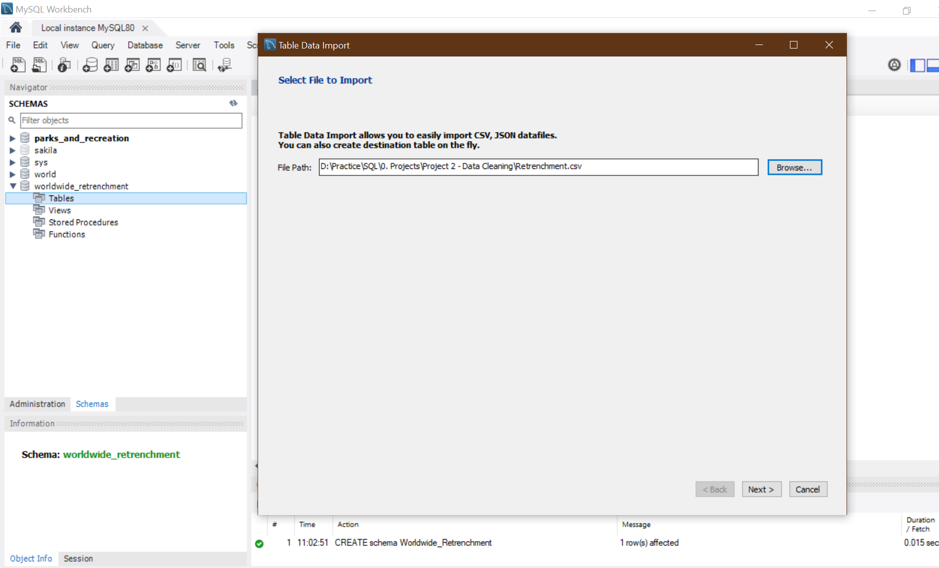

1. Add table name as **Retrenchment** in create new table. Select “Drop Table if exists”. Then click on **Next**

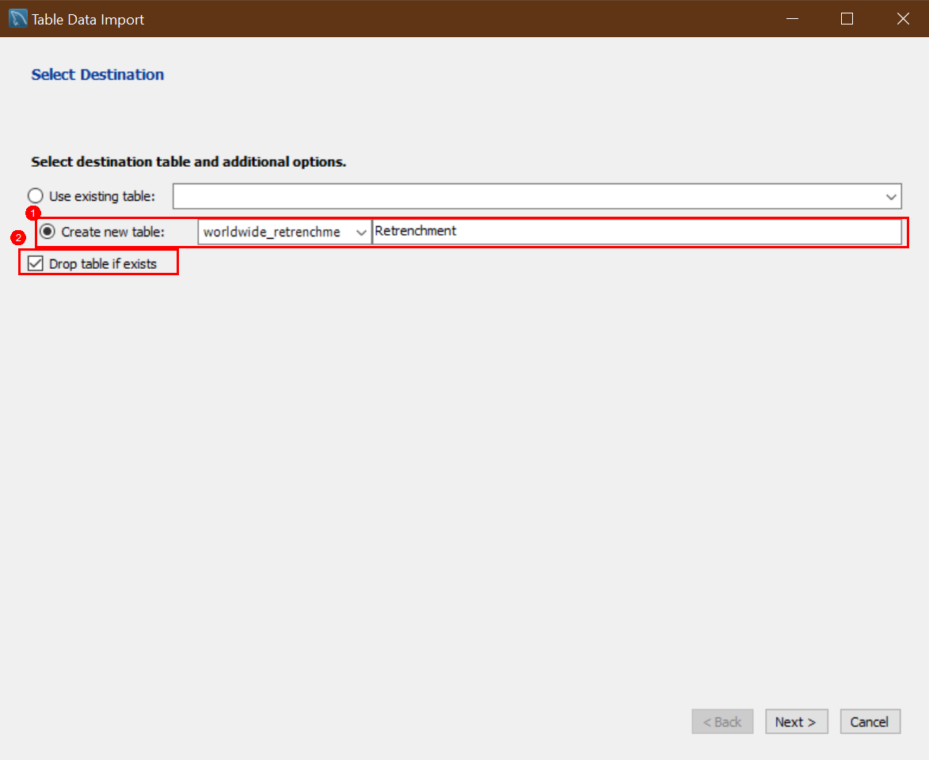

1. No need to change the variable type at this point as we have to do the data cleansing later. Click on **Next**.

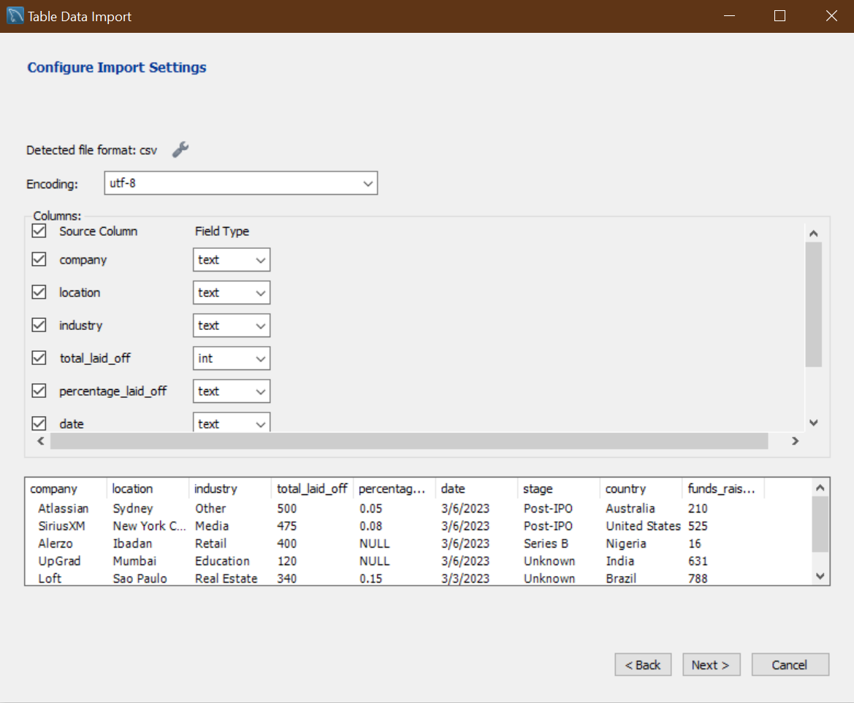

1. Click on **Next** to execute the **Prepare Import** and **Import Data File** tasks.

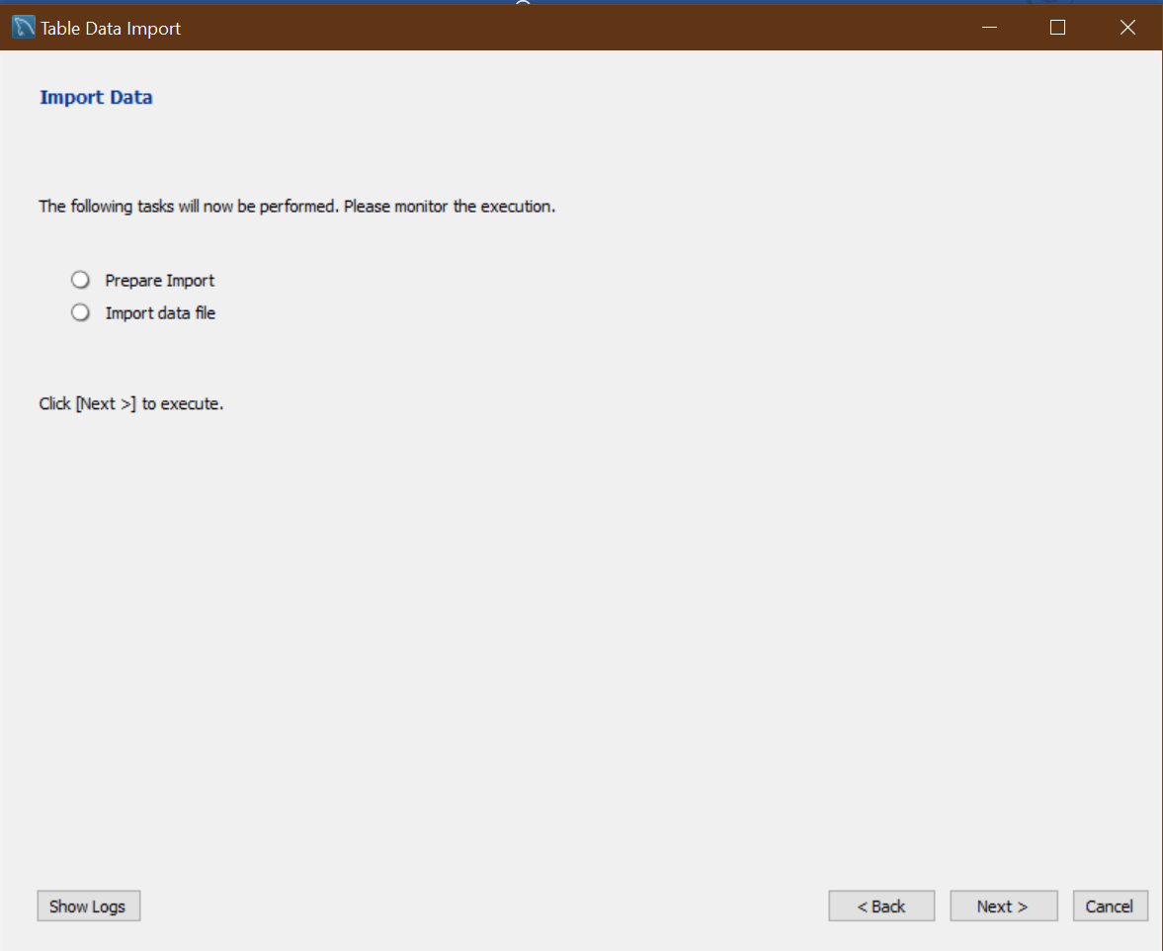

1. Once it is completed then below highlighted text will appear. Click on **Next**

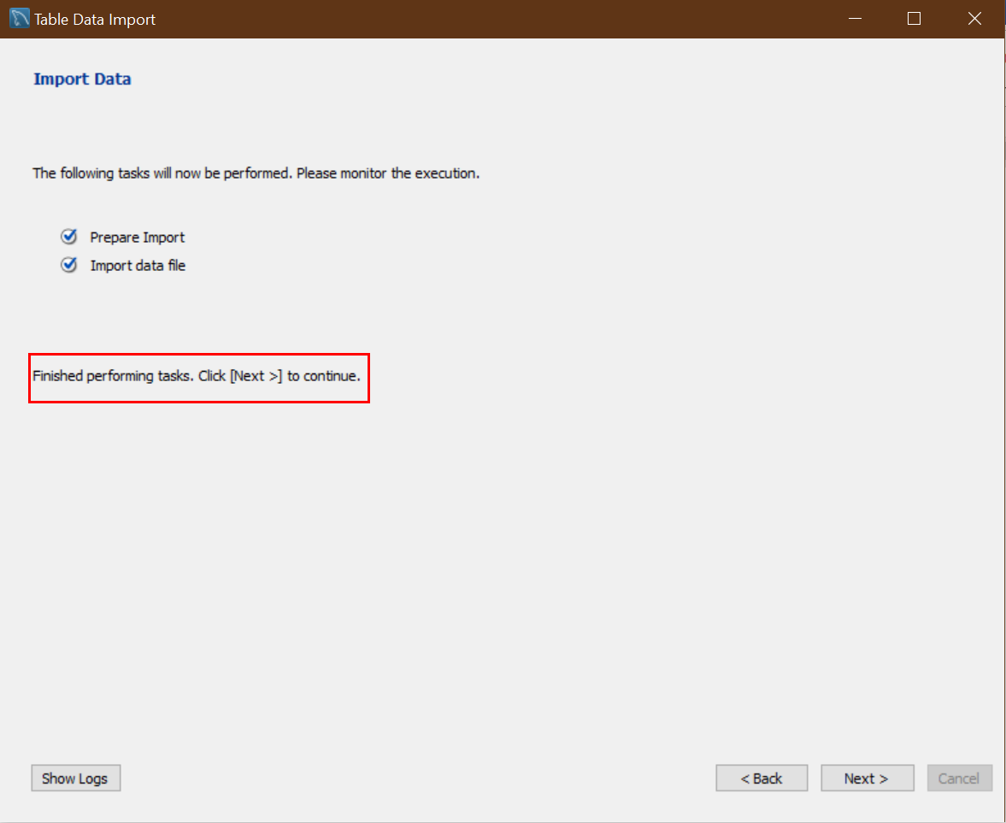

1. At this page, we can see how many records have been imported. Click on **Finish**.

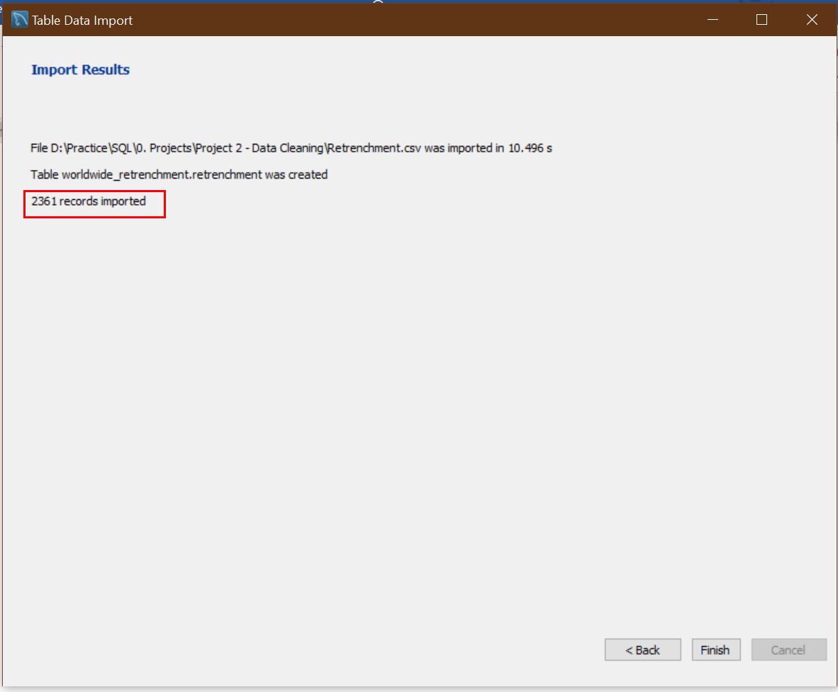

1. Under created database, Click on **refresh** button.

